**Name:Muhammad Shaheer**

**Roll no:20p-0480.**

**LAB Task 1 Data Structures**

Q1: Populate an array of your size choice and write a program to find the largest and smallest element in that array

**Coding:**

#include<iostream>

using namespace std;

int main()

{

    //declaring array and assign size

    int arr[5];

    int min,max;

    //Enter values

    cout<<"Enter values in array:"<<endl;

    for(int i=0;i<=4;i++)

    {

        cin>>arr[i];

    }

    //printing array

    cout<<"Array elements are:"<<endl;

    for(int i=0;i<=4;i++)

    {

        cout<<arr[i]<<"\t";

    }

    //To find min and max of aray

    min=arr[0];

    max=arr[0];

    cout<<endl;

    for(int i=0;i<=4;i++)

    {

        if(arr[i]<min)

        {

        min=arr[i];

        }

        if(arr[i]>max)

        {

        max=arr[i];

        }

    }

    cout<<"The smallest element in array is :"<<min<<endl;

    cout<<"The largest element in array is :"<<max<<endl;

    return 0;

}

**Output:**

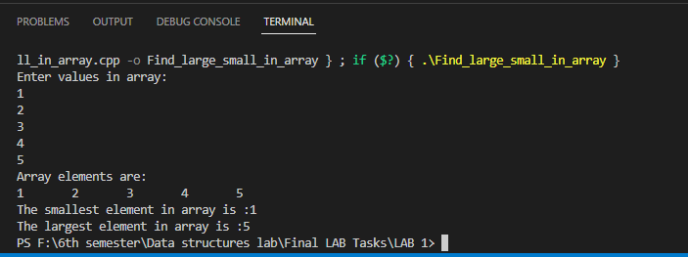

**Q2:** Given an array of integers nums and an integer target, return indices of the two numbers such that they add up to target. You may assume that each input would have exactly one solution, and you may not use the same element twice. You can return the answer in any order.

**Coding:**

#include<iostream>

using namespace std;

int main()

{

    //declaring array and assign size

    int arr[5];

    int target=9;

    //Enter values

    cout<<"Enter values in array:"<<endl;

    for(int i=0;i<=4;i++)

    {

        cin>>arr[i];

    }

    //printing array

    cout<<"Array elements are:"<<endl;

    for(int i=0;i<=4;i++)

    {

        cout<<arr[i]<<"\t";

    }

    for(int i=0;i<4;i++)

    {

        for (int j=i+1;j<4;j++)

        {

        if(arr[i]+arr[j]==target)

        {

            cout<<"Taget acheived"<<endl;

            cout<<"With elements "<<endl<<arr[i]<<"\t"<<arr[j]<<endl;

            cout<<"target ="<<target<<endl;

        }

        }

    }

    //else{

      //      cout<<"you miss target"<<endl;

        //}

    return 0;

}

**Output:**

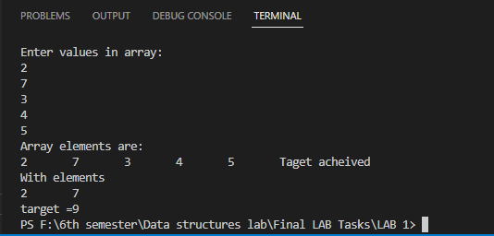

**Q3:** Write a function find_small_val(int A[] ) that given an array A of N integers, returns the smallest positive integer (greater than 0) that does not occur in A. For example, given A = [1, 3, 6, 4, 1, 2], the function should return 5.

**Coding:**

#include<iostream>

using namespace std;

int find_small_val(int A[],int size ){

for (int i = 1; i <= size; i++)         //for element check

{

    for (int j = 0; j < size; j++)          //whole array element check

    {

        // Handling only negative case here

        if (A[j]<0)             //if value is less then go in

        {            if(i==A[j]){       //if value of i not equal not in usuall this case will not be true and it goes end if condition (after positive check)

            //  it is true when first is negative and other value is positive

            if(i==size)

            {

                return i+1;

            }

         else if (i!=A[j] && j+1==size)

         {

            return i;

         }else {

         return 1;

         }

                            break;

        }

}

// Here positive case :

              if(i==A[j]){      //if value is equal inside

         if(i==size)            //check the last value

            {

                return i+1;

            }

                    break;

         }if (i!=A[j] && j+1==size)         //if value is not inside and and it check the whole array just return that missing value

         {

            return i;

         }

    }

}

    }

int main(){

    // int A[]={1,3,6,4,1,2};

 int A[] = {2, -1,-3 };

int size=3;

int answer;

answer=find_small_val(A,size);

cout<<"The answer is :"<<answer<<endl;

return 0;

}

**Output:**

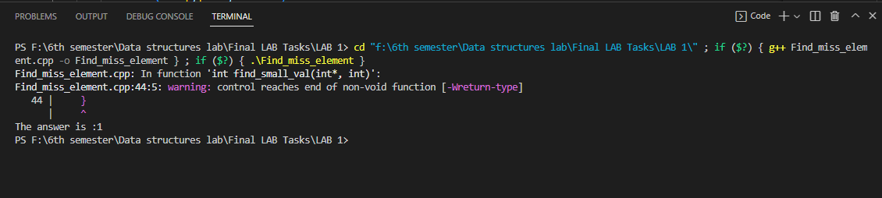

**THE END_________________________________.**